Homework 2: Simple Neural Network

Course: Computational Intelligence and Adversarial Learning

Janzaib Masood

Department of Electrical and Computer Engineering

Auburn University

# Code Modification:

The code for the homework was modified to test a single ‘sigma’ value 30 times. The average of the 30 F1-scores and 30 accuracies was considered for the analysis. The sigma values were tested in the range of 0.01 to 1.6. The figure given below show the relationship found between sigma values and the two metrics. 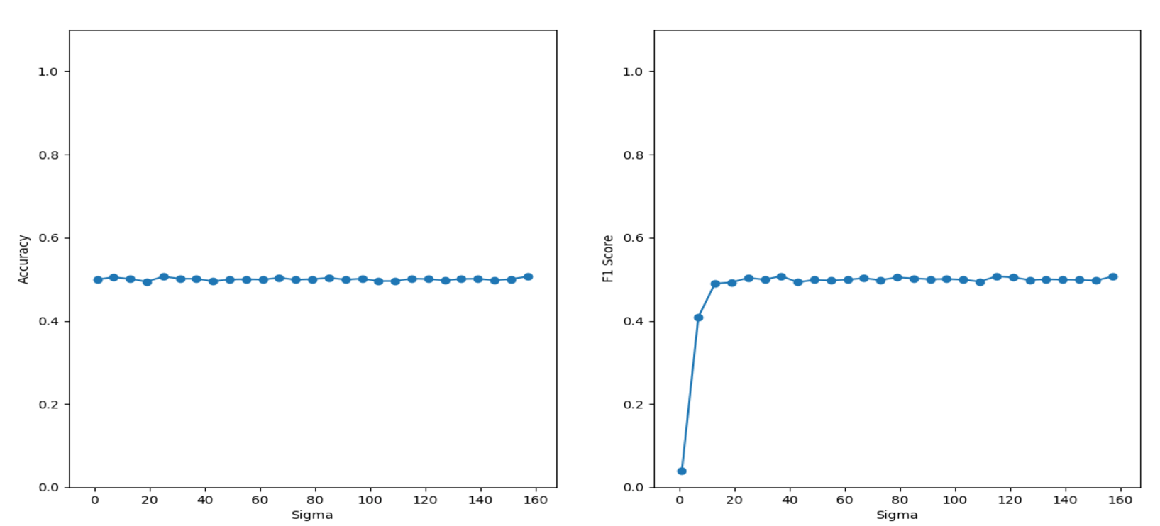

# Question 1: Discover a value for ‘sigma’ that maximizes the F1-Score.

A value of sigma that maximizes the F1-score in my experiment is 0.41.

# Question 2: Discover a value for ‘sigma’ that maximizes the accuracy.

A value of sigma that maximizes the accuracy in my experiment is 0.35.

# Question 3: Are the two values of sigma the same?

The values of sigma that maximize the both efficiency metrics are close but not necessarily the same.

I think the F1-score is very close to accuracy for most of the sigma values, because the data distribution is even.